**What is DreamBox?**

DreamBox Learning is an online software provider that focuses on mathematics education at the elementary and middle school level.

**HOW TO LOG IN:**

**STEP 1:** Log in with website link below which is specific to our school.

**LINK: https://play.dreambox.com/login/khda/fyhr**

School Code: khda/fyhr

**STEP 2:** Log in with your scholar’s username (firsnamelast initial ex. amirab) and text password. No email address is needed for the child.

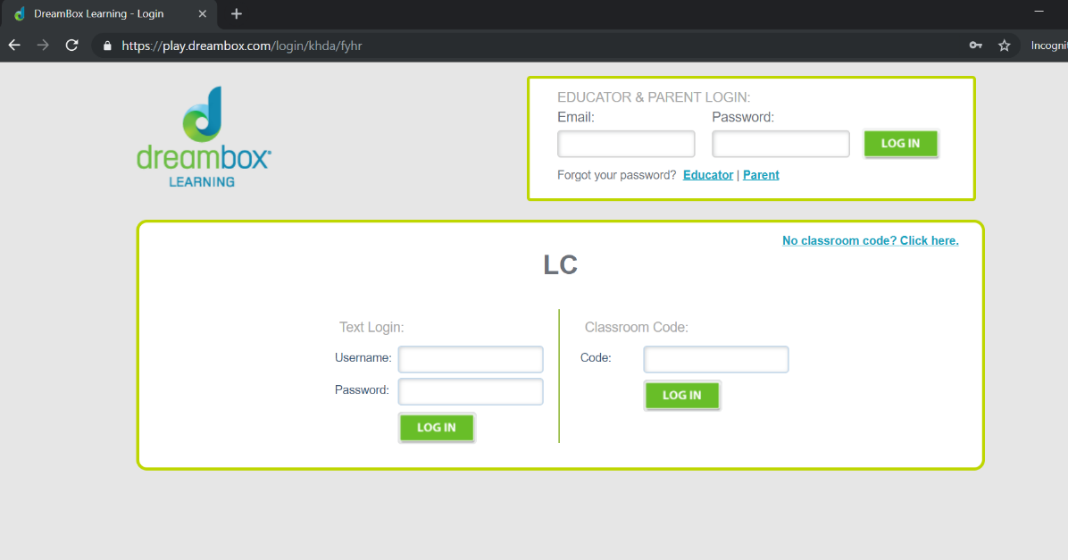

**STEP 3:** Once they log in, under the welcome image playing, there is a little blue link you can click that says *“****Set up parent access”***. Then enter your email address to track your child's progress going forward.

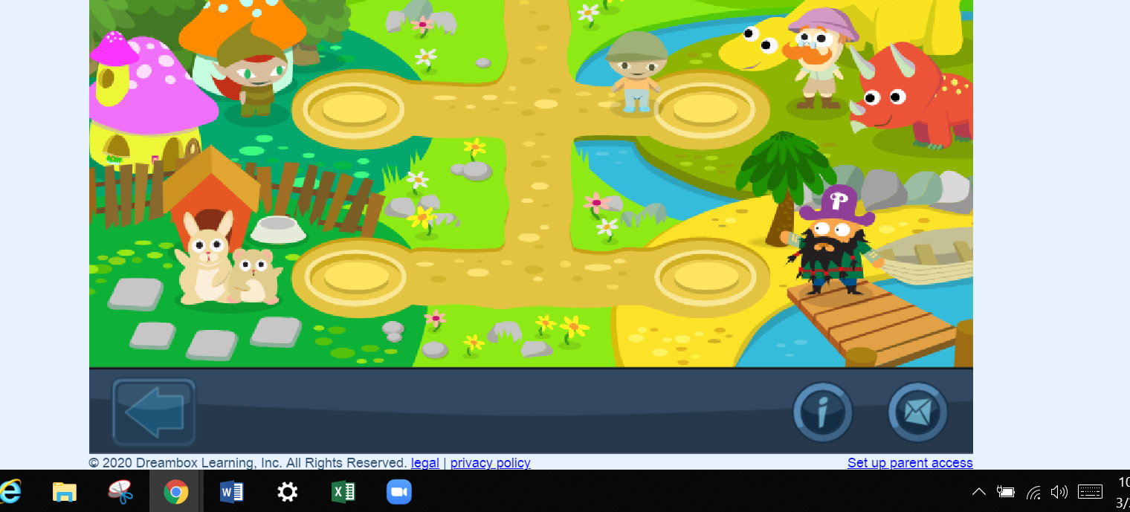

**STEP 4:** The link will direct you to the **“Parent Account Setup”** page. 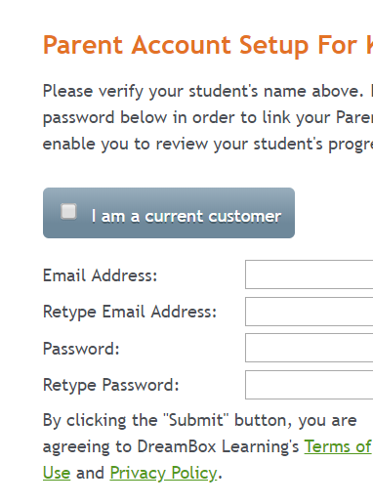Fill out the form and hit the **“Submit”** button.