Troubleshooting for students

Trouble signing in

I can't sign in to Classroom:
You might be trying to sign in to Classroom with the wrong account. Check that you’re using the email account connected to Classroom. You sign in to Classroom with one of these accounts:
- School account—Also known as a G Suite for Education account, this account is set up by an accredited school. It looks like you@yourschool.edu.
Note: You must have an active Internet connection to sign in.

If you can’t sign in with the correct email account and password, maybe your school’s administrator doesn’t automatically activate Classroom for new students and users. Ask your teacher.

I forgot my password:
If your school uses G Suite for Education—Ask your teacher to contact the admin to reset your password.

Classroom in the incorrect languages

How do I change the language in Classroom?
You change the preferred language for your Google Account. For details, see Change language to change the language on computer and mobile devices.

Trouble signing out

How do I sign out?
Computer Android iPhone & iPad
When you sign out of your account, you sign out from all G Suite products on your device.
- In Classroom, at the top right, click your photo.
  - If you don't see a photo, you may see the Account image .
- Click Sign out.
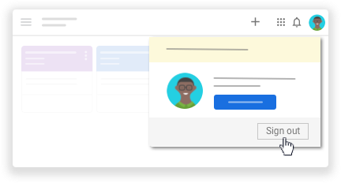

Trouble accessing classes

My class code doesn't work
If your school uses G Suite for Education—Ask your teacher to send you a new class code. If the new class code doesn’t work, ask your teacher to contact the school’s admin.
- A class code consists of 6 or 7 alphanumeric characters. For example, hjhmgrk or g5gdp1.
Note: You only use the class code once to enroll. You don't need to re-use the class code.

I deleted or forgot my class code
If you deleted, lost, or forgot the class code before adding yourself to a class, ask your teacher to resend the code or set a new one.
Note: You only use the class code once to join the class. You are then enrolled in the class and you don't need to re-use the code again.

I deleted my class invitation
If you lose your class invitation before you added yourself to a class, ask your teacher to resend the class invitation.
Note: You only use the class invitation once to enroll. You don't need to re-use the class invitation again.

I unenrolled from a class and want to re-enroll
If you accidentally unenrolled from a class, ask your teacher to resend you a class code or invitation.

Trouble posting comments

I can't post a comment
Your teacher turned off posting for that class. Ask your teacher for more information.

How do I undelete a post?
You can’t undelete a post. However, your teacher can see all your deleted posts.

Trouble with email and messages

I can't send or receive email
If your school uses G Suite for Education—Your school’s admin might have turned off Gmail for students. Ask your teacher to contact the admin.
If you’re a student using a personal Google Account outside of a school—See Gmail Help.

