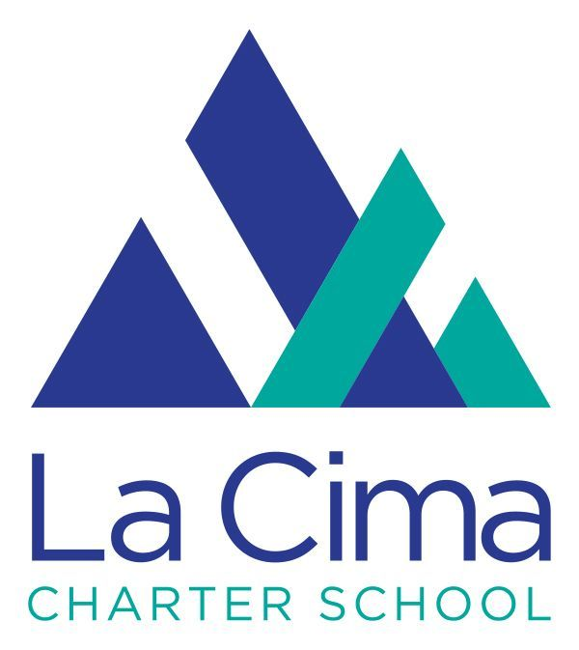

Board and Committee Meetings for the 2021-2022 SY

AUGUST 2021
Governance Committee- Wednesday, August 11
Academic Committee- Monday, August 16
Finance Committee- Wednesday, August 18
Executive Committee- Thursday, August 19
Board Meeting- Wednesday, August 25

SEPTEMBER 2021
Governance Committee- Wednesday, September 8
Academic Committee- Monday, September 20
Finance Committee- Wednesday, September 22
Executive Committee- Thursday, September 23
Board Meeting- Wednesday, September 22

OCTOBER 2021
Governance Committee- Wednesday, October 13
Academic Committee- Monday, October 18
Finance Committee- Wednesday, October 20
Executive Committee- Thursday, October 21
Board Meeting- Wednesday, October 27

NOVEMBER 2021
Governance Committee- Wednesday, November 3
Academic Committee- Monday, November 8
Finance Committee- Wednesday, November 10
Executive Committee- Thursday, November 11
Board Meeting- Wednesday, November 17

DECEMBER 2021
Governance Committee- Wednesday, December 1
Academic Committee- Monday, December 6
Finance Committee- Wednesday, December 8
Executive Committee- Thursday, December 9
Board Meeting- Wednesday, December 15

JANUARY 2022
Academic Committee- Monday, January 5
Finance Committee- Wednesday, January 10
Executive Committee- Thursday, January 14
Board Meeting- Wednesday, January 20

FEBRUARY 2022
Governance Committee- Wednesday, February 2
Academic Committee- Monday, February 7
Finance Committee- Wednesday, February 9
Executive Committee- Thursday, February 10
Board Meeting- Wednesday, February 16

MARCH 2022
Governance Committee- Wednesday, March 9
Academic Committee- Monday, March 14
Finance Committee- Wednesday, March 16
Executive Committee- Thursday, March 17
Board Meeting- Wednesday, March 30

APRIL 2022
Governance Committee- Wednesday, April 6
Academic Committee- Monday, April 11
Finance Committee- Wednesday, April 13
Executive Committee- Thursday, April 14
Board Meeting- Wednesday, April 27

MAY 2022
Governance Committee- Wednesday, May 11
Academic Committee- Monday, May 16
Finance Committee- Wednesday, May 18
Executive Committee- Thursday, May 19
Board Meeting- Wednesday, May 25

JUNE 2022
Governance Committee- Wednesday, June 1
Academic Committee- Monday, June 6
Finance Committee- Wednesday, June 8
Executive Committee- Thursday, June 9
Board Meeting- Wednesday, June 15

